**[Using Artificial Neural Networks to Predict Emergency Department Deaths](https://dzone.com/articles/apache-spark-machine-learning-using-artificial-neu)**

**Problem Statement:**

We will try to predict patient deaths during ED visits due to heart disease based on various patient characteristics such as age, basic vital measurements and presence of myocardial infarction, i.e. heart attack.

**Target Label:**

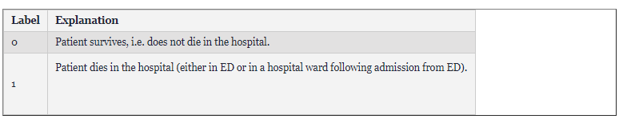

**Features Selected:**

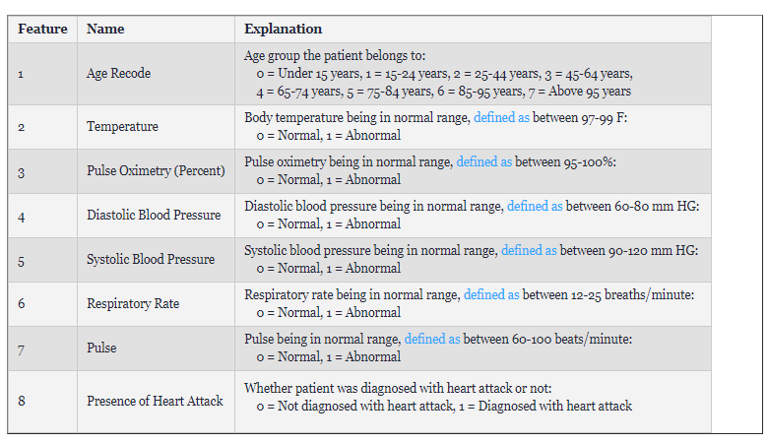

Our model actually selected most of these features. What’s different, however, is that they modified the features slightly. For example, instead of having a value for the Pulse, they defined ranges and they only state whether it is **Normal** or **Abnormal**.

**The Chosen Model: Neural Networks**

In this paper, the authors use Neural Networks. Initially, their model had 2 hidden layers, each of which contained 5 neurons. After some modifications, they reached the final model with 2 hidden layer; the first contains 28 neurons and the second contains 25 neurons.

**Results:**

For the initial Model:

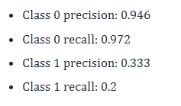

For the final Model:

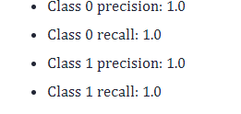

Comment: Even though the final model seems more accurate, the model might be overfitting.